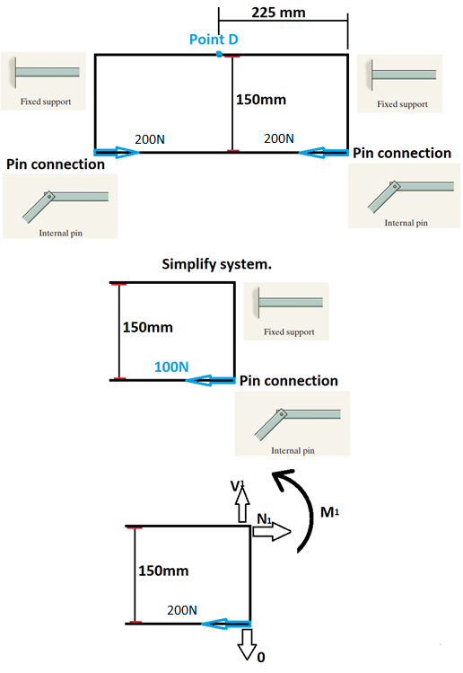
∑Fx=N1-200=0
N1=200
∑ Fy=0
V=0
∑ M=0
M1-0.150m*200N=0
M1=30Nm
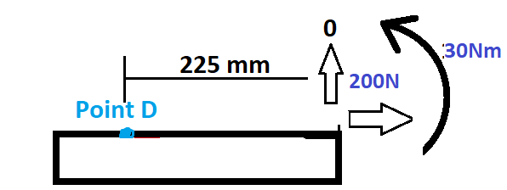

N a-a=-200 Answer
M a-a=-30Nm Answer
V a-a=0 Answer
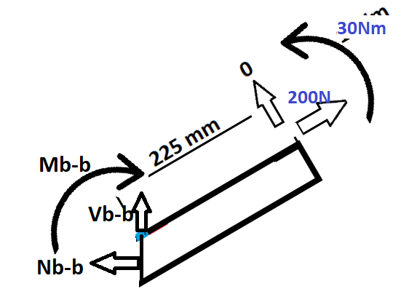
N a-a=-200*cos(30)= -173.2N Answer
M a-a=-30Nm Answer
V a-a=200*sin(30) = 100N Answer
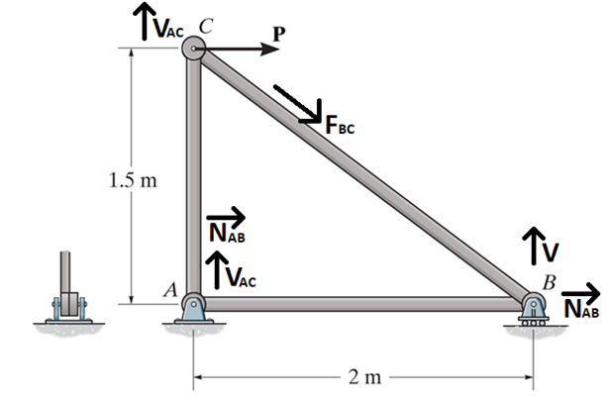
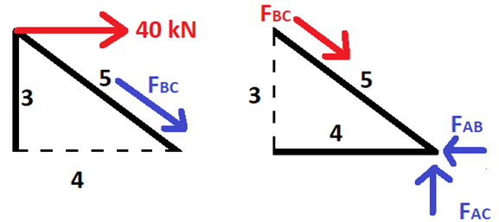
∑Fx=0=FBC*4/5-40kN
FBC=50kN
∑Fy=0= FAC-FBC*3/5
FAC=30kN
∑Fx=0=FAB-FBC*4/5
FAB=40kN
N/A=Stress=σ
σBC=50kN/(0.010m^2*π) = 500MN/π =159154943 Pascals ≅ 159.15 MPa ANSWER
σAC=30kN/(0.010m^2*π) = 300MN/π =95492965 Pascals ≅ 95.49MPa ANSWER
σAB=40kN/(0.010m^2*π) = 400MN/π =127323954 Pascals ≅ 127.32MPa ANSWER

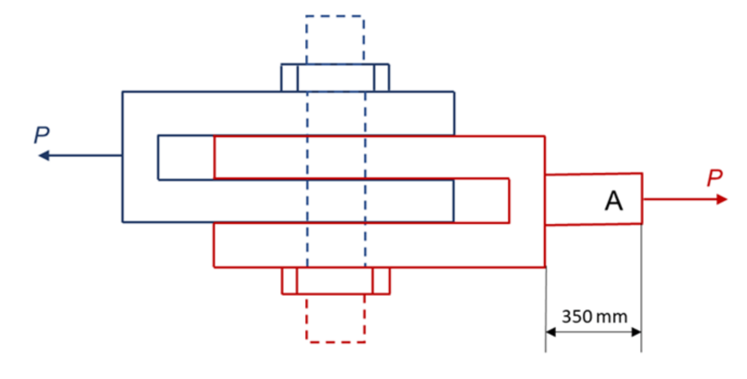
Τ=V/A
200MPa=V/(0.03^2*π)→V=180πkN = 565486.678N= 565.5kN
180πkN*3=540πkN=1.7MN
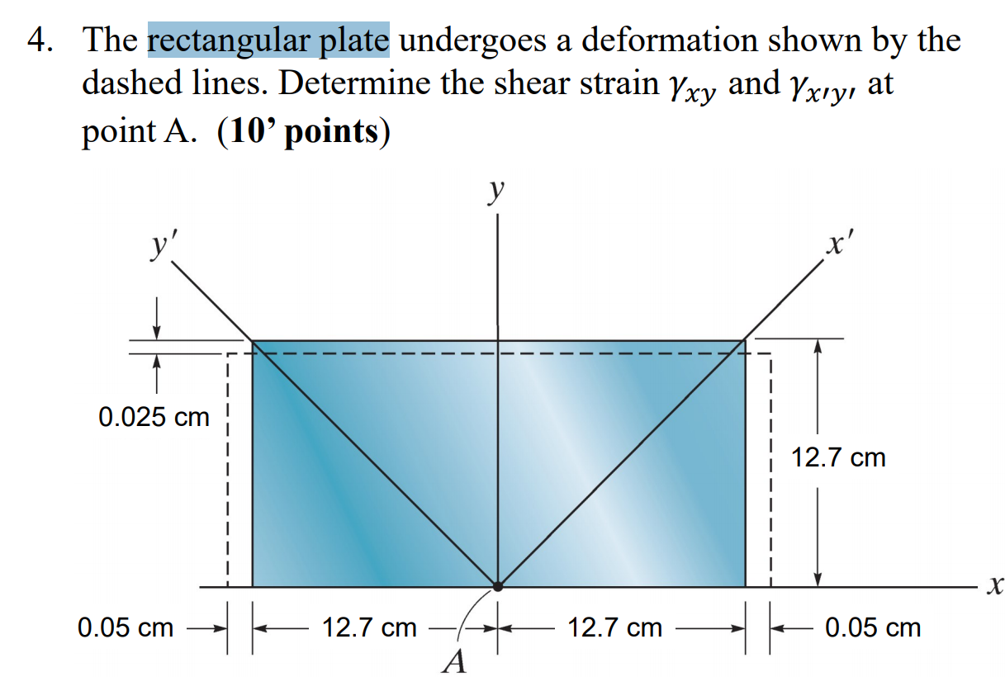
$$γ_{xy}=0$$
$$γ_{x'y'}=\frac{π}{2}-2*arctan\left(\frac{12.75}{12.675}\right)=0.338°=-0.0058996882rad$$
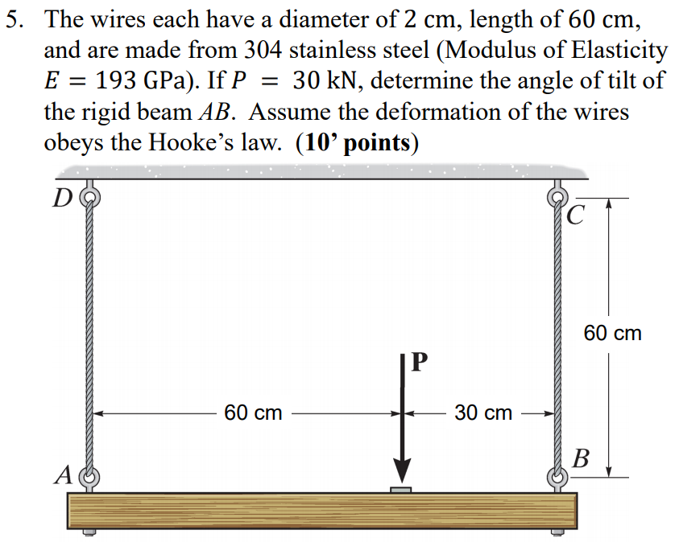
Force at A=10kN= 1/3(P)
Force at B=20kN= 2/3(P)
L0=0.6m
$$σ=E*ϵ$$
$$\frac{N}{A}=E*\frac{δ}{L_{0}}$$
$$\frac{10,000N}{π {0.01}^{2}}=193*{10}^{9} Pa*\frac{δ m}{0.6 m}; δ=9.89564*{10}^{-5}$$
$$\frac{20,000N}{π {0.01}^{2}}=193*{10}^{9} Pa*\frac{δ m}{0.6 m}; δ=1.97913*{10}^{-4}$$
$$difference between final lengths of cables=9.89564{*10}^{-5}m$$
Calculate angle
$$\tan\left(θ°\right)=\frac{9.89564{*10}^{-5}}{0.9}→θ=6.30*{10}^{-3}degrees=1.0995*{10}^{-4}radians$$

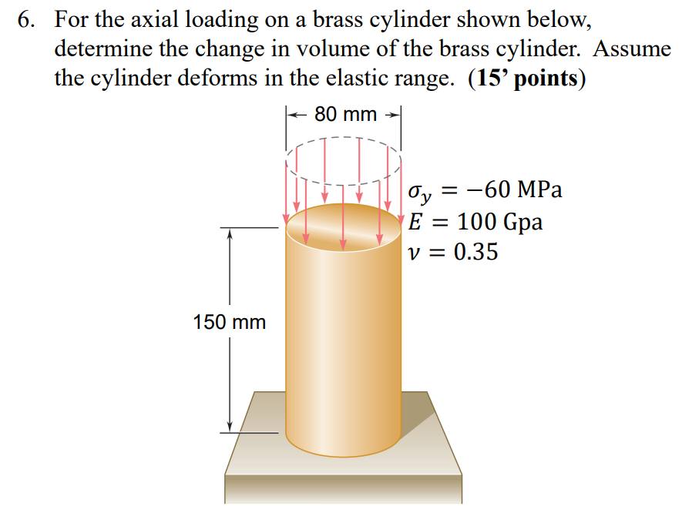
$$ϵ=-\frac{60*{10}^{6}Pa}{100*{10}^{9}Pa}=-0.0006 m/m$$
$$δz=ϵ*L→δ=-600*{10}^{-6}*1.5=-900μm height change$$
$$ϵ=-0.35*-600*\frac{{10}^{-6}mm}{mm}=\frac{0.00021m}{m}$$
$$δx=\frac{0.00021m}{m}*0.08m=0.00021*0.08=16.8μm diameter change$$
$$volume change$$
$$\left(1.5\right)*π*\frac{{\left(0.08\right)}^{2}}{4}=0.0075398223686{ m}^{3}$$
$$\left(1.5-900*{10}^{-6}\right)*π*\frac{{\left(0.08+16.8*{10}^{-6}\right)}^{2}}{4}=0.0075384636328 m^{3}$$
Difference = $0.0075398223686-0.0075384636328=0.0000013587358m^{3}=1.3587358{cm}^{3}$

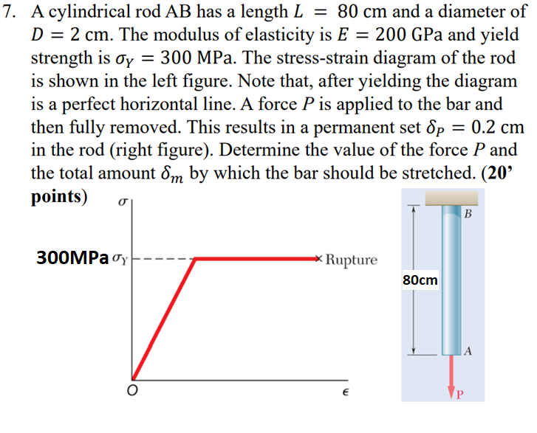
$$Force=σ_{Y}*A_{0}; ε =strain; ε_{total}=\frac{δ_{m}}{L_{0}};ε_{Y}=\frac{σ_{Y}}{E}$$
$$ε_{plastic}+ε_{elastic}=ε_{total}; δ_{p}=permanent set=ε_{plastic}*L_{0}$$

$$Force=σ_{Y}*A_{0}→FORCE P=300MPa*{0.01}^{2}*π=30,000π N≅94.247kN$$
$$ε_{Y}=ε_{elastic}$$
$$ε_{Y}=\frac{σ_{Y}}{E}→\frac{300MPa}{200GPa}=1.5*{{10}^{-3}m}/m$$
$$δ_{p}=permanent set=ε_{plastic}*L_{0}→0.002m=0.8m*ε_{plastic}→2.5*10^{-3}m/m$$
$$ε_{plastic}+ε_{elastic}=ε_{total}→2.5*{{10}^{-3}m}/m+1.5*{{10}^{-3}m}/m=4*{{10}^{-3}m}/m$$
$$ε_{total}=\frac{δ_{m}}{L_{0}}→4*{{10}^{-3}m}/m=\frac{δ_{m}}{0.8m}→δ_{m}=3.2*{10}^{-3}m=0.32cm$$

